6 Day Tasmanian Wilderness and Wine

Inclusions: Highly qualified and knowledgeable guide, travel in luxury air-conditioned vehicle, private airport pick up and drop off, 2 nights accommodation in an executive Waterfront Suite at Macq 01 including breakfast daily, day tour to Huon Valley and Bruny Island including lunch, travel by boat and entry to MONA including lunch at The Source, private transfer to Freycinet Lodge, 3 nights accommodation in a Mountain Terrace King Room including breakfast daily, Wine Glass Bay tour, private walking tour, exclusive wine tasting and return transfer to Hobart and expert commentary.

Day 1

Hobart Arrival

Welcome to Hobart. On arrival today, your private driver will meet you at the baggage carousel at Hobart Airport and escort you to an awaiting luxury vehicle for your transfer to the Macq 01. Situated on the edge of Constitution Dock and in the heart of Hobart, Macq 01 is contemporary luxury at its best. Check into your Executive Waterfront Suite for the next 2 nights. The rest of the day is yours to enjoy.

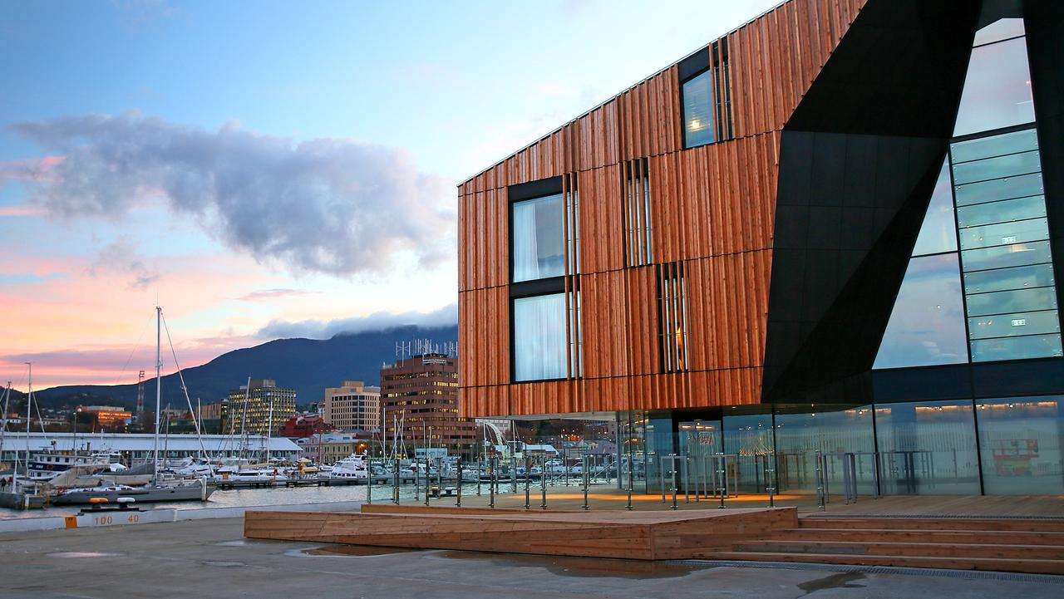

Maybe explore the local area including nearby Salamanca Place and the historical Battery Point. Discover the local cafes, pubs and wine bars and settle in for the night.

Day 2

Huon Valley and Bruny Island

Your guide will meet you at 9am this morning for an amazing tour of the stunning Huon Valley. Head south out of the city to the small town of Kettering. Here board a car ferry that takes you across the crystal clear waters of the D’Entrecasteaux Channel to the charming Bruny Island. With a geographical size of Singapore and a population of only 4000, Bruny Island is naturally beautiful and untouched.

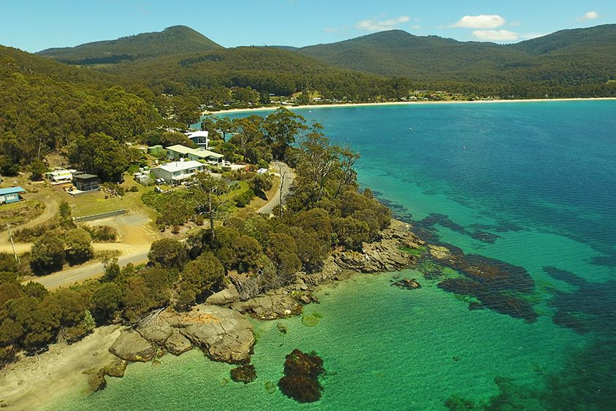

Our first stop this morning is at Bruny Island Berries for some morning tea. Enjoy some coffee with your fresh berries or maybe some locally grown honey. Traverse the Eastern side of the island discovering tall eucalypt forests. Our next stop is Get Shucked Oysters. Fresh from the crystal clear and cold Southern Ocean, oysters are plucked straight from the water and then shucked for you to enjoy, maybe with a glass of local wine. A truly unique experience. Reboarding the vehicle, we now head back to the ferry and across to the mainland. We turn South on the Chanel Highway towards the picturesque town of Cygnet, in the heart of the Huon Valley. This area is scattered with fruit orchards including apples, pears and stone fruits. We make a stop at one of the many road side stalls to pick up some fresh fruit along the way.
Lunch today is at the stunning Home Hill Winery, situated in the small village of Ranelagh. Enjoy a beautiful lunch accompanied by matching wines overlooking the vast estate. Sit back and relax and enjoy your surrounds.

After a relaxing lunch rejoin your vehicle once more and make the short drive to Willie Smiths, one of Tasmania’s oldest orchards and now a cider producer. In rustic surrounds of an original apple shed built in 1942, learn about the regions fascinating apple heritage told through the eyes of Willie Smith. Today you will be able to taste several of their refreshing ciders. From Willie Smiths, we now continue back towards Hobart, climbing the impressive Mount Wellington. At over 1250 meters above sea level, Mount Wellington provides incredible views of the city and surrounding countryside. Afterwards your guide will drop you back to your hotel at around 5pm.

Day 3

MONA and the Freycinet Peninsula

Your guide will meet you at 9am this morning to walk you the short distance to the Brooke Street Pier. Hop aboard the waiting boat, the Mona Roma, and you are on your way the world famous Museum of New and Old Art (MONA). Upon entering the boat, turn left and make your way to the Business Class Seating, also known as the Posh Pit. Sit back, relax and enjoy some fine Tasmanian wine, champagne and produce. Or maybe just a coffee. Observe the stunning views as you travel up the Derwent River towards the museum.
On arrival you will be impressed with the stunning sandstone entrance atop a cliff. Enter the mirrored doors and be prepared to be amazed by a thought provoking and eclectic collection
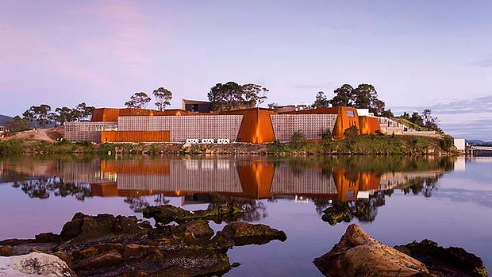

of art and displays. MONA exhibits everything from ancient Egyptian funerary objects and modernists master pieces to a machine that mimics the human digestive system. You will need a couple of hours to discover all that the museum has to offer. Enjoy.
Lunch today is MONA’s own restaurant, The Source. Perfectly situated at the top level of MONA, enjoy surrounding views and the exceptional menu.
After lunch your guide will be waiting to transfer you to the Freycinet Peninsula. Sit back and relax in your luxury vehicle and enjoy this very scenic 3 hour drive. Marvel at the stunning coastal views all the way to Coles Bay, before entering the Freycinet National Park. Your accommodation for the next 3 nights is at the spectacular Freycinet Lodge, located in the heart of the National Park. You are booked into a Mountain Terrace Room.
Settle into the stunning surrounds of the lodge and the rest of the afternoon is yours to enjoy. Explore the local area on foot or simply relax.

Day 4

Freycinet Peninsula

Enjoy a leisurely breakfast this morning in the main lodge with its gorgeous views over the water.
Later this morning we have arranged a wonderful cruise on the nearby Wineglass Bay. Board your luxury Eco Catamaran and discover this world heritage listed area on a stunning 4.5 hour cruise.

Explore the crystal blue waters, hidden sea caves and towering granite cliffs of Freycinet National Park.

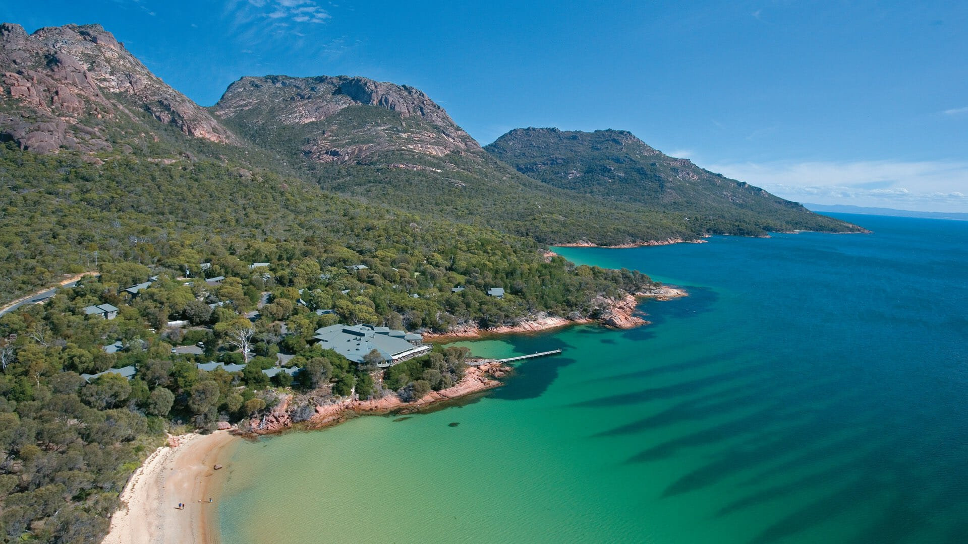

Learn about the rich natural and aboriginal history of the area while cruising along side dolphins, whales and fur seals. Enjoy a delicious ploughman’s lunch of fresh local produce and cool climate wines.

Afterwards return to the Lodge and the rest of the day is yours to enjoy.
Later this evening, we have arranged an exclusive wine tasting. Join your reserved seating overlooking Great Oyster Bay for a wonderful tasting of some of the best local Tasmanian Wines.

Later settle in for dinner.

Day 5
Explore the Freycinet Peninsula

Enjoy breakfast again this morning at your leisure.
Later this morning we have arranged a private walking tourof the nearby National Park. Departing the lodge, enjoy a 5.5 hour educational and immersive guided walk to some of the parks most loved destinations, including Wineglass Bay and Hazards Beach. Your knowledgeable guide will explain about the unique animals that call this special place home and the history behind its stunning shores and pink granite peaks.

Enjoy a specially prepared picnic lunch before returning to the lodge by private water taxi.
The rest of the day is yours to enjoy.

Day 6
Depart Tasmania.

Your private driver will meet you this morning at Freycinet Lodge and transfer you back directly to Hobart Airport for your onward flight.

